App-of-Apps Lab — Complete Hands-on

Instead of creating two ArgoCD Applications manually, we create ONE Root Application, and that Root Application creates the Child Applications automatically.

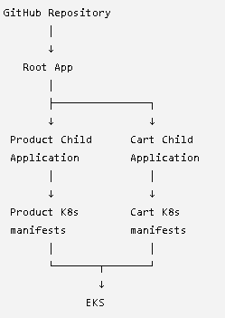

We will use two applications:
- product
- cart
https://github.com/letslearn207/flipkart-gitops (FORK THE REPO)
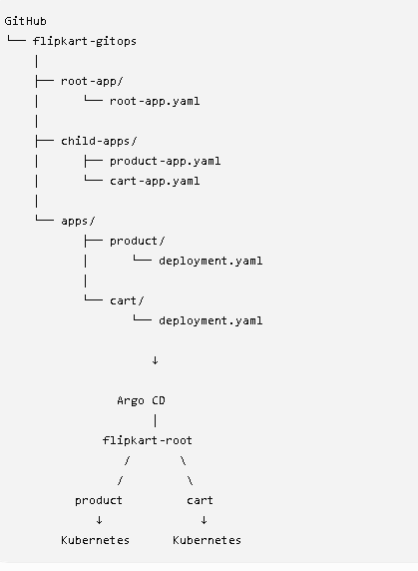

## GO TO THE kubectl MACHINE
git clone https://github.com/letslearn207/flipkart-gitops.git
cd flipkart-gitops
apt install tree
tree
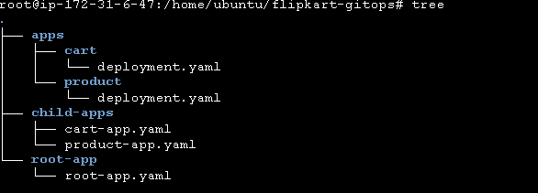

kubectl apply -f root-app/root-app.yaml
What just happened?
You have not directly deployed Product or Cart yet.
You only created this:
Kubernetes
│
└── ArgoCD
│
└── flipkart-root
The Root Application now tells ArgoCD:
"Go to my GitHub repository and look inside child-apps/."
Inside child-apps/, ArgoCD will find:
product-app.yaml
cart-app.yaml
So ArgoCD should then create those two Child Applications.

Step 7 — Check the Applications
Run:
kubectl get applications -n argocd
Initially you may see only:
NAME SYNC STATUS HEALTH STATUS
flipkart-root Synced Healthy
Wait a few seconds and run it again:
kubectl get applications -n argocd
You should eventually see:
NAME SYNC STATUS HEALTH STATUS
flipkart-root Synced Healthy
product Synced Healthy
cart Synced Healthy

This is the important moment of the lab
You applied only one YAML:
root-app.yaml
But ArgoCD discovered:
product-app.yaml
cart-app.yaml
and created the Child Applications.
That's the App-of-Apps pattern
##





